Name: Sapargali Temirlan
Group: SE-2403
Instructor: Aigul Adamova
PART 6
1. Problem Definition
The Urban Parking Crisis
In major urban centers like Astana and Almaty, drivers waste an average of 20+ minutes daily searching for parking, contributing to congestion, fuel waste, and frustration. Simultaneously, a vast inventory of private parking spaces (residential, corporate) remains unused for significant portions of the day. Existing solutions are inadequate: traditional lots are expensive and inflexible, while centralized peer-to-peer (P2P) applications act as rent-seeking intermediaries, charging 20-30% commissions while creating single points of failure and trust dependency.
My Blockchain Solution: Parkware
Parkware is a decentralized, blockchain-based peer-to-peer parking marketplace that directly connects parking space owners with drivers. By leveraging Ethereum smart contracts and Layer 2 scaling, we eliminate the need for a trusted third party. Payments are held in a secure, automated escrow and released only upon successful completion of the parking session. This creates a transparent, secure, and cost-efficient system that reduces platform fees to 10-15%, returning greater value to users and unlocking underutilized urban assets.
2. Technical Scope
Contracts Involved
ParkwareCore: The main escrow contract managing the entire booking lifecycle (listing, payment, release).
PWToken: An ERC-20 utility token for platform payments, discounts, and future governance.
ParkwareRegistry: Manages user profiles, spot metadata, and reputation scores.
DisputeResolver (Future): Handles arbitration for conflicts, potentially involving community jurors.
Key Functionalities
For Space Owners: List spots with dynamic pricing, set availability, receive automated crypto/fiat payments.
For Drivers: Search/filter available spots, book instantly, pay via escrow, check-in/out via mobile.
Core Protocol: Time-locked smart contract escrow, automatic payout upon successful session completion, platform commission collection.
Token Utility: Pay with PW for reduced fees, earn PW as rewards for network participation.
Planned Libraries & Standards
OpenZeppelin Contracts: For secure, audited implementations of ERC-20, Ownable, and ReentrancyGuard.
Chainlink Oracles: For reliable fiat price feeds (KZT/USD) and, potentially, proof-of-presence data.
EIP-712 & EIP-2612: For gasless token approvals and improved user experience.
Storage Structures
On-Chain (Ethereum L2): Critical state—escrow balances, user token balances, booking statuses (minimal, expensive).
Off-Chain Decentralized (IPFS): Metadata—spot descriptions, photos, user ratings (cost-effective, immutable references).
Off-Chain Centralized (Backend DB): Ephemeral data—search indexes, session cookies (for performance).
Expected Gas-Heavy Areas
Booking Creation & Finalization: Each involves multiple state changes (escrow lock, status update) and emits events.
Batch Operations: Paying out multiple owners simultaneously or airdropping tokens.
Complex Dispute Resolution: Multi-step arbitration with voting from multiple jurors.
Attack Surfaces & Mitigation
Reentrancy: Use OpenZeppelin's ReentrancyGuard modifier on all state-changing functions in the core escrow.
Integer Overflow/Underflow: Rely on Solidity compiler v0.8.x+ which has built-in checks, or use OpenZeppelin's SafeMath for critical logic.
Oracle Manipulation: Use decentralized oracle networks (Chainlink) for price data, not a single source.
Front-Running: Implement commit-reveal schemes for spot booking if necessary, or accept it as a minor UX cost in v1.
Denial-of-Service (DoS): Set reasonable gas limits per transaction and avoid loops over unbounded arrays.
3. Architecture Diagram
System Overview & Data Flow
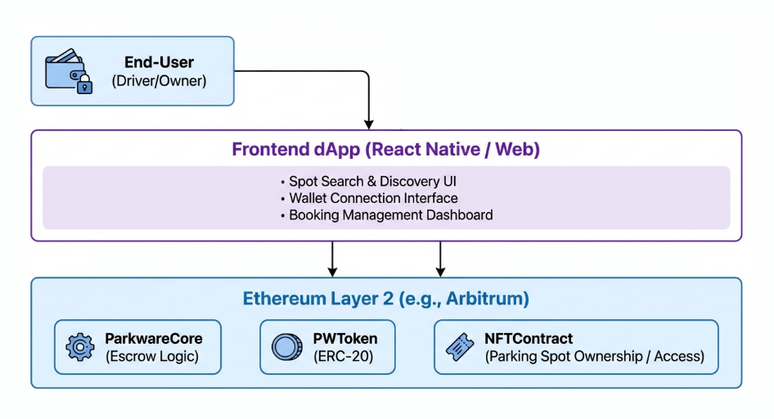
Key Interactions Explained
User to dApp: A driver uses the React Native app to find a spot. Spot details (images, description) are fetched from IPFS via a CID stored on-chain.
dApp to Blockchain: The user's wallet (MetaMask) signs a transaction to the ParkwareCore contract to book and pay.
Smart Contract Execution: The ParkwareCore contract locks funds in escrow, emitting a Booked event.
Oracle Integration: For final payout, the contract may query a Chainlink Price Feed to convert a KZT price to the correct amount of PW tokens.
Completion: After check-out, the driver confirms. The contract automatically releases payment to the owner and commission to the treasury.
4. Risk Assessment
Economic Risks
Cryptocurrency Volatility: The value of the PW token and ETH (for gas) could fluctuate wildly, creating user uncertainty.
Mitigation: Integrate a fiat on-ramp/off-ramp so users can transact in KZT without knowing they're using crypto. The platform can absorb conversion risk or use instant stablecoin swaps.
High Gas Fees on Ethereum Mainnet: Could make micro-transactions (parking) economically unviable.
Mitigation: Architect for Layer 2 from day one. Deploy initially on a low-cost, EVM-compatible L2 like Arbitrum or Polygon.
Security Risks
Smart Contract Vulnerabilities: Bugs could lead to loss of all user funds.
Mitigation: Mandatory professional audits before launch (e.g., from firms like ConsenSys Diligence), followed by a public bug bounty program. Use battle-tested libraries like OpenZeppelin.
Private Key Management: Users losing keys or having wallets hacked.
Mitigation: Partner with custodial wallet providers or explore social recovery wallets for a smoother user onboarding, while educating users on seed phrase safety.
Technical Limitations
Blockchain Throughput: Even on L2, transaction finality is slower than traditional databases.
Mitigation: Design the UX to manage expectations (e.g., "Processing..." screens). Keep the most frequent actions (search, filtering) completely off-chain.
User Experience Complexity: Requiring users to understand wallets, gas, and confirmation pop-ups is a major adoption barrier.
Mitigation: Develop an abstracted onboarding flow. The app can sponsor initial gas fees (gasless transactions via meta-transactions) and manage key interactions in the background.
By addressing this comprehensive scope and its associated risks, Parkware will be positioned not just as a proof-of-concept, but as a viable, secure, and user-friendly product ready for pilot launch and iterative development.

